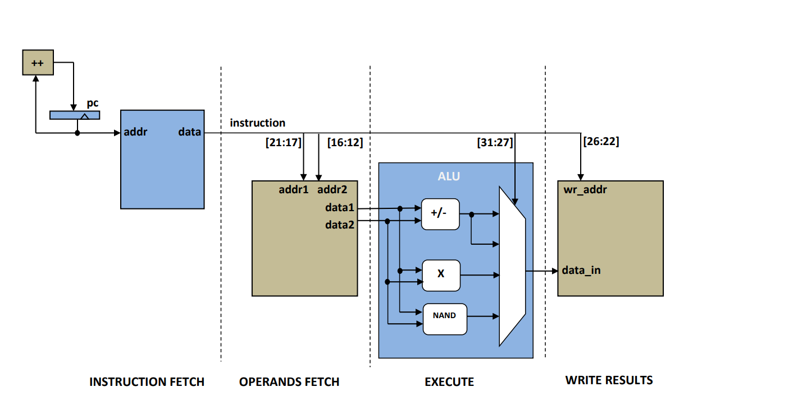

// blue box contains Instruction Fetch & program counter //// Data Memory // need to add the **program.hex**  **data_file.txt I used block ram**

module bram

   #(

      parameter RAM_WIDTH     = 32,

      parameter RAM_ADDR_BITS    = 9,

      parameter DATA_FILE     = "data_file.txt",

      parameter INIT_START_ADDR  = 0,

      parameter INIT_END_ADDR    = 10

   )

   (

   input                   clock,

   input                   ram_enable,

   input                   write_enable,

    input      [RAM_ADDR_BITS-1:0]  address,

    input      [RAM_WIDTH-1:0]   input_data,

   output reg  [RAM_WIDTH-1:0]   output_data

   );

   (* RAM_STYLE="BLOCK" *)

   reg [RAM_WIDTH-1:0] ram_name [(2**RAM_ADDR_BITS)-1:0];

   //  The forllowing code is only necessary if you wish to initialize the RAM

   //  contents via an external file (use $readmemb for binary data)

   initial

      $readmemh(DATA_FILE, ram_name, INIT_START_ADDR, INIT_END_ADDR);

   always @(posedge clock)

      if (ram_enable) begin

         if (write_enable)

            ram_name[address] <= input_data;

         output_data <= ram_name[address];

      end

endmodule

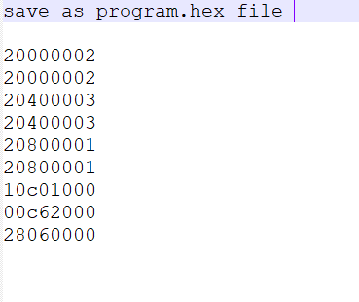 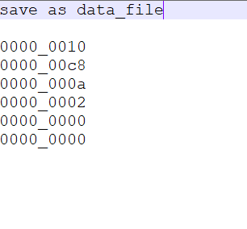

**//green box is register file**

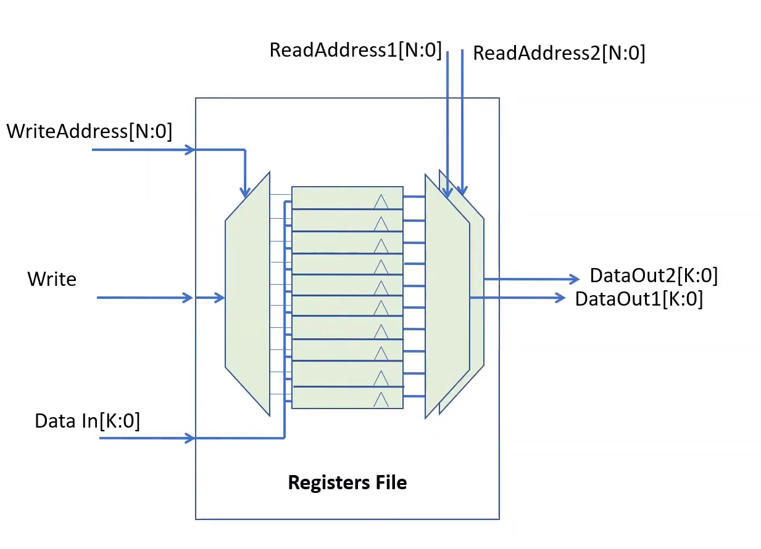

**//THIS IS DATA STORAGE FILE // Operand Fetch & Write back**

//THIS IS DATA STORAGE FILE

module reg_file(

        input           clk,

        input   [4:0]   rd_addr1,

        input   [4:0]   rd_addr2,

        output  [31:0]  rd_data1,

        output  [31:0]  rd_data2,

        input   [4:0]   wr_addr,

        input           wr_en,

        input   [31:0]  wr_data

);

reg [31:0] regs[0:31];

always@(posedge clk)

    if(wr_en)   regs[wr_addr] <= wr_data;

assign  rd_data1 = regs[rd_addr1];

assign  rd_data2 = regs[rd_addr2];

endmodule

**// ALU and execute**

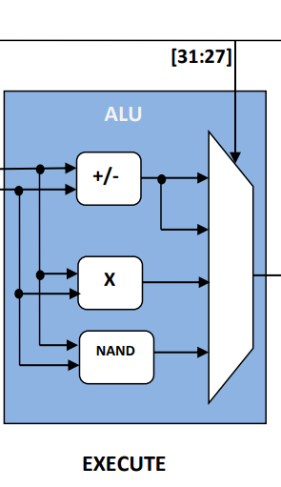

//THIS IS COMPELETE processor FOR NEWBIES

module processor

    #(

        parameter RAM_WIDTH         = 32,

        parameter RAM_ADDR_BITS     = 9,

        parameter DATA_FILE         = "data_file.txt",

        parameter DATA_START_ADDR   = 0,

        parameter DATA_END_ADDR     = 5,

        parameter PROG_FILE         = "program.hex",  // A= B + C*D -- B=200 C=10 D=2

        parameter PROG_START_ADDR   = 0,

        parameter PROG_END_ADDR     = 8

    )

(

    input clk,

    input reset

);

parameter ADD  = 'd0;

parameter SUB  = 'd1;

parameter MUL  = 'd2;

parameter NAND = 'd3;

parameter LW   = 'd4;

parameter SW   = 'd5;

reg     [RAM_ADDR_BITS-1:0] prog_cnt;

wire    [RAM_WIDTH-1:0]     instr;

wire    [RAM_WIDTH-1:0]     op1;

wire    [RAM_WIDTH-1:0]     op2;

reg     [RAM_WIDTH-1:0]     alu_out;

reg     [RAM_WIDTH-1:0]     reg_data_in;

wire    [RAM_WIDTH-1:0]     dram_data_out;

reg     [4:0]               opcode;

reg                     ctl1,ctl2,ctl3;

// Instruction Fetch

always@(posedge clk)

    if(reset)   prog_cnt <= 0;

    else        prog_cnt <= prog_cnt + 1;

bram

#(

    .RAM_WIDTH      (RAM_WIDTH          ),

    .RAM_ADDR_BITS  (RAM_ADDR_BITS      ),

    .DATA_FILE      (PROG_FILE          ),

    .INIT_START_ADDR(PROG_START_ADDR    ),

    .INIT_END_ADDR  (PROG_END_ADDR      )

)

prog_mem

(

    .clock          (clk            ),

    .ram_enable     (1'b1           ),

    .write_enable   (1'b0           ),

    .address        (prog_cnt       ),

    .input_data     (0              ),

    .output_data    (instr          )

);

// Operand Fetch & Write back

reg_file regfile_inst

(

        .clk            (clk),

        .rd_addr1       (instr[21:17]),

        .rd_addr2       (instr[16:12]),

        .rd_data1       (op1),

        .rd_data2       (op2),

        .wr_addr        (instr[26:22]),

        .wr_en          (ctl1),

        .wr_data        (reg_data_in)

);

// ALU

always@* opcode = instr[31:27];

always@*

    case(opcode[1:0])

    ADD : alu_out =   op1 + op2;

    SUB : alu_out =   op1 - op2;

    MUL : alu_out =   op1 * op2;

    NAND: alu_out = ~(op1 & op2);

    endcase

always@* reg_data_in = ctl2 ? dram_data_out : alu_out;

// Data Memory

bram

#(

    .RAM_WIDTH      (RAM_WIDTH      ),

    .RAM_ADDR_BITS  (RAM_ADDR_BITS  ),

    .DATA_FILE      (DATA_FILE      ),

    .INIT_START_ADDR(DATA_START_ADDR),

    .INIT_END_ADDR  (DATA_END_ADDR  )

)

data_mem

(

    .clock          (clk            ),

    .ram_enable     (1'b1           ),

    .write_enable   (ctl3           ),

    .address        (instr[8:0]     ),

    .input_data     (op1            ),

    .output_data    (dram_data_out  )

);

// Control Signals

always@* ctl1 = ~ctl3;

always@* ctl2 = opcode == LW;

always@* ctl3 = opcode == SW;

endmodule